**Shahaan Mirza**

**Papademas**

**ITMD 411**

**Final Project Snapshots**

Program Description:

This program acts as a ticket management system. Allowing users to open and close tickets which are stored in a MySQL Database. The database, along with Admin features, are accessible only to the administrators. The administrators are able to Update, Delete, and View tickets – in addition to Opening and Closing tickets.

userlist.csv

**MySQL View**

Insert Ten Tickets

Update My Ticket (ID:1) Description

Delete My Ticket (ID:1)

Close Two Tickets

**GUI View**

Login Screen

Login Menu [Wrong Credentials]

Main Menu[Admin:True]

Main Menu [Admin:False]

Admin Submenu

Ticket Submenu

Open A Ticket [1]

Open A Ticket [2]

Open A Ticket [3]

Update A Ticket [1]

Update A Ticket [2]

Update A Ticket [3]

Update A Ticket [4]

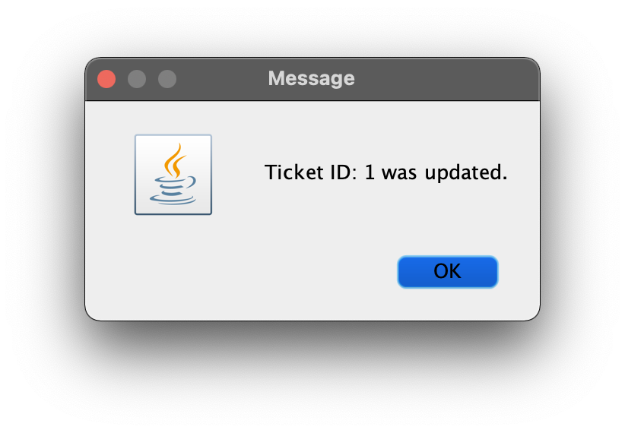

View Tickets

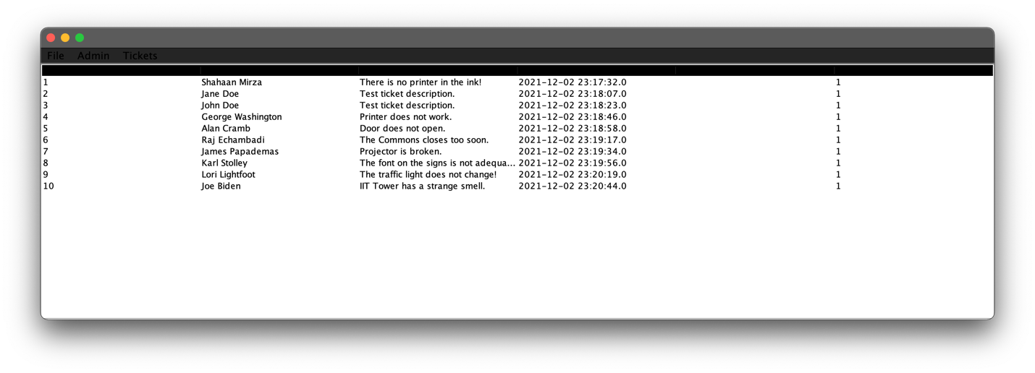

Delete A Ticket [1]

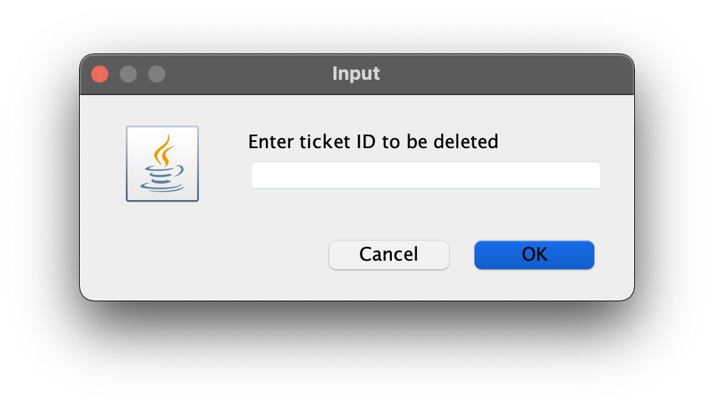

Delete A Ticket [2]

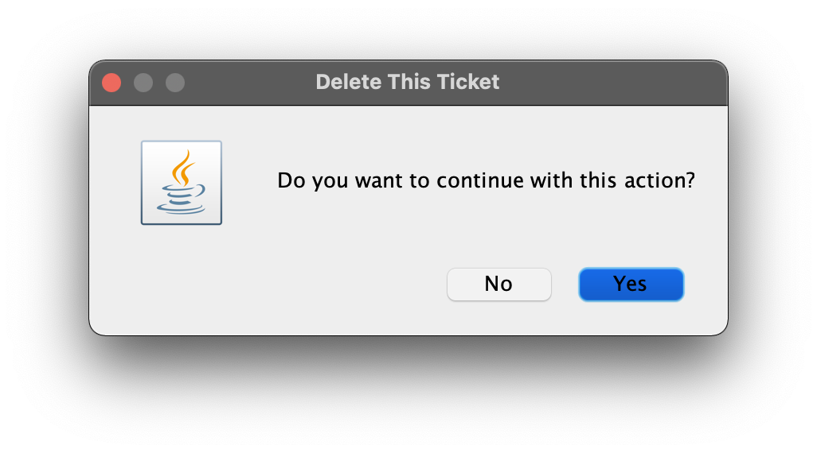

Delete A Ticket [3]

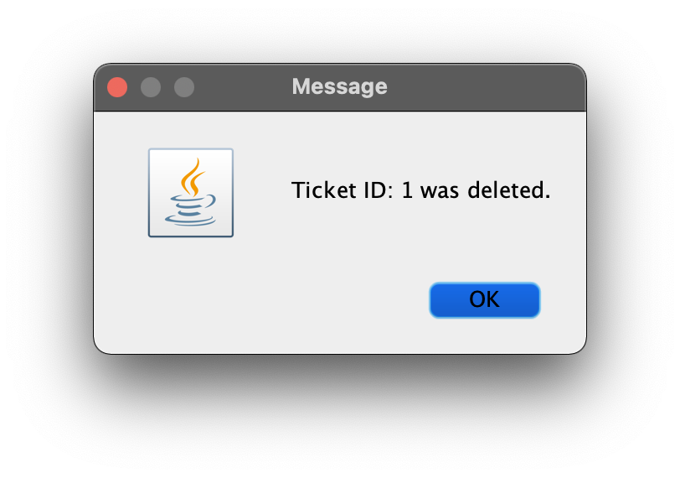

Close A Ticket [1]

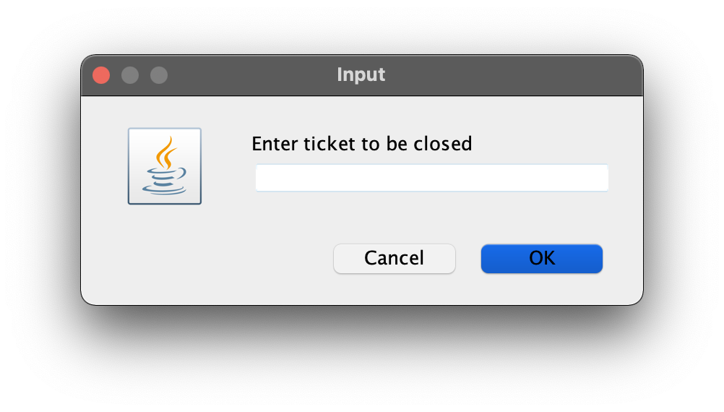

Close A Ticket [2]

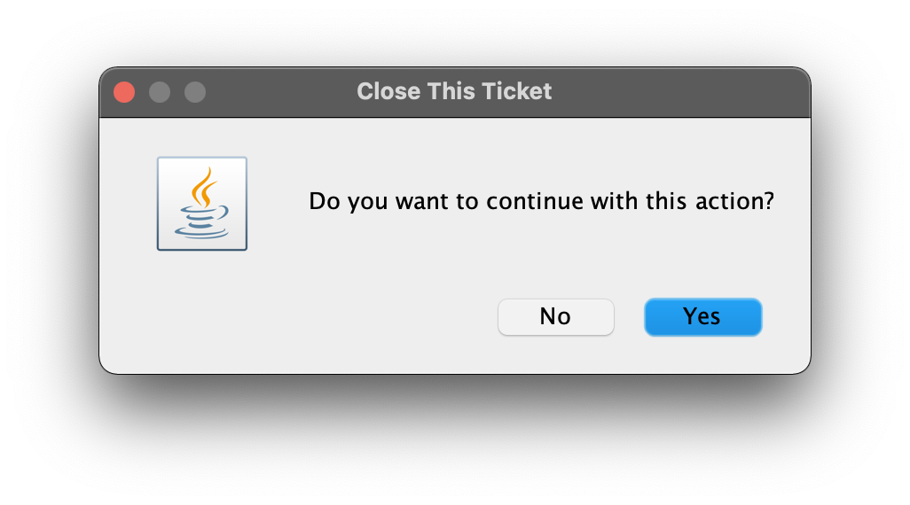

Close A Ticket [3]

